
PROJECT WORK
NAME: CHINMAY MOHAPATRA
REG. NO.: 25BAI10986
ACTIVITY: PROJECT
FACULTY: Dr. KANAN
COURSE: DIGITAL LITERACY

TASK 1
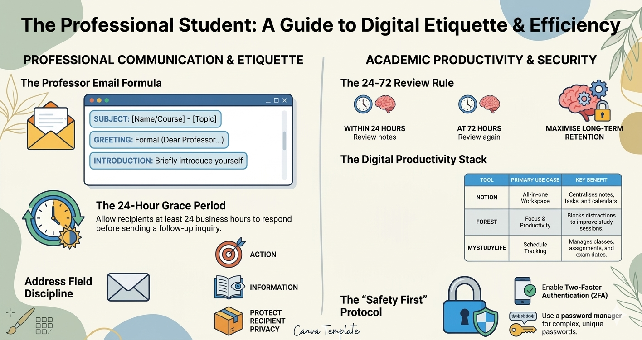
Tool Used:
I utilized Canva as the primary design platform, owing to its user-friendly interface, diverse template library, and advanced visual customization features. It enabled me to create a clean, structured, and aesthetically professional layout without requiring extensive graphic design expertise.
Overview of the Design:
The design, titled “The Professional Student: A Guide to Digital Etiquette & Efficiency,” focuses on enhancing academic discipline and communication standards. It is divided into two key sections:
- Professional Communication & Etiquette: Covers the professor email formula, emphasizing subject clarity, formal greetings, and concise introductions. It also includes the 24-hour grace period and address field discipline.
- Academic Productivity & Security: Highlights the 24–72 review rule to improve retention, introduces a digital productivity stack (tools for note-taking, focus, and scheduling), and emphasizes cybersecurity practices such as two-factor authentication and password management.
Key Learning / Challenge:
One particularly interesting aspect was achieving a balance between visual appeal and informational density. Organizing multiple concepts without overcrowding the design required thoughtful spacing, consistent colour schemes, and appropriate icon selection. Maintaining a professional tone while keeping the content engaging was initially challenging but ultimately strengthened the clarity and impact of the final output.

TASK 2

